Workday Integration Design Kick-Off
Cornerstone • Selective Insurance • Kainos

1. In-Scope Integrations
- Cornerstone Cost Center Outbound
- Currently there is a flat CC structure in Cornerstone
- CCH was entered into data KDT so we will need to account for cost center hierarchy structuring
- Cornerstone Demographics Outbound
- Cornerstone Divisions Outbound
- Cornerstone Locations Outbound
- Position Feed (current feed today; not on original SOW)
  - Job family rather than specific positions

Cutover Tasks:
Upload one time feed to update Positions and Locations from Workday to Cornerstone (if 1:1 changes)
Inactivate items that are no longer needed in Cornerstone

2. Timeline

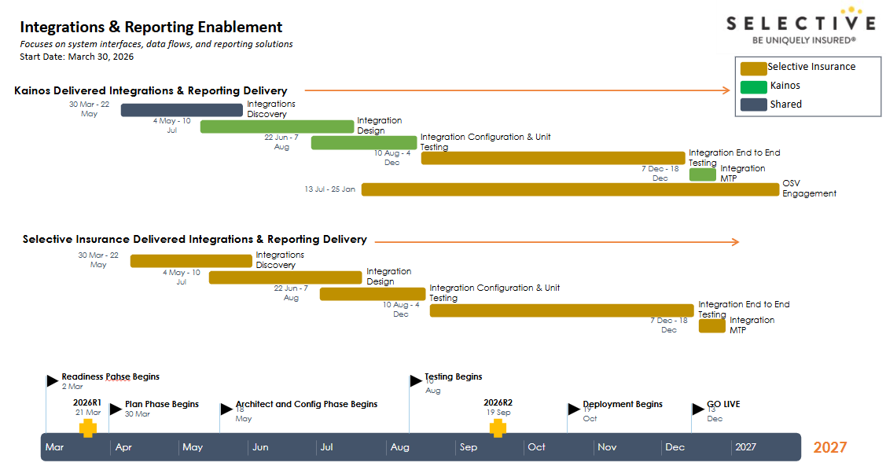

3. Key Contacts
Vendor Technical Contacts: rwinzer@csod.com Robin Winzer
Business Contacts: kristin.delade@selective.com Kristin DeLade

4. Getting Started
- Is there a test environment for file exchanges? If not, how do you prefer to validate without impacting production?
  - Pilot Cornerstone environment currently exists and was recently copied down from production
- Any lead times or internal steps we need to plan for (approvals, SOWs, security reviews)?
  - Cornerstone offers coaching hours ; not development hours ; cornerstone will walk selective team through how to update their cornerstone system but will not make any changes themselves
- What are the vendor steps and lead times (cert exchange, IP allowlist, firewall approvals, folder setup)?
  - Kristin to open a ticket to create ftp setup to pilot environment
  - FTP already setup ; Will need to reach out to setup another one strictly for test environment port 22
- What authentication/encryption standards apply?
  - PGP encryption is allowed and used currently
  - Username / password only ; PGP exists currently ; want pgp future state as well

5. Scoping Questions
- What is current state?
  - Currently Cost Centers, Employee Demographics, Divisions, Locations and Positions are sent from UKG in a full file daily feed to Cornerstone. These are separate file feeds running at 2pm on Cornerstone Production Environment. Cornerstone does full file validation to determine what details have been changed or removed.
- Are there dependencies on file load order (e.g., cost centers must load before demographics)?
  - No, feed runs all files at one time.
  - Will give error if certain is file is missing; email notification can be setup to send upon errors
- Can any files be combined?
  - No ; individual files needed
- Are all these files currently sent from UKG to Cornerstone? Are cost centers sent from Peoplesoft?
  - All feeds are coming from UKG currently
- Will the org structure remain the same? (i.e. Same organization codes and names will be replicated in Workday)? Any mapping layer required (Workday value ≠ Cornerstone value)?
  - Locations have changed (1:1 change) ; Locations have time zones as well (required field)
  - 1 time upload could be leveraged if we send a file with existing location ids and new location ids
  - Cost center hierarchy
- What demographic data needs to be sent?
  - Sample files to be sent by Sara
- How are terminations handled?
  - Term by omission
  - Employment status is not sent ; only send active employees
- Any employee / cost centers / divisions / locations to be excluded from population?
  - Inactive employees would be removed from file feed
  - There are only certain groups that will be sent to cornerstone ; this is based on position / job family (Sara to help with access to view the logic on this rule)
  - Might have some filters on positions/ jobs that are sent over
- Full file employees or only employee changes?
  - Full files for active orgs and employees
  - Allow reconcile is set to true ; meaning term by omission would become true
- What defines a “location” in Cornerstone? (Physical work location? Remote/home locations?)
  - Location = office location
- How often should files be sent?
  - Daily @2am est
  - .txt files

